Union Pacific Tour

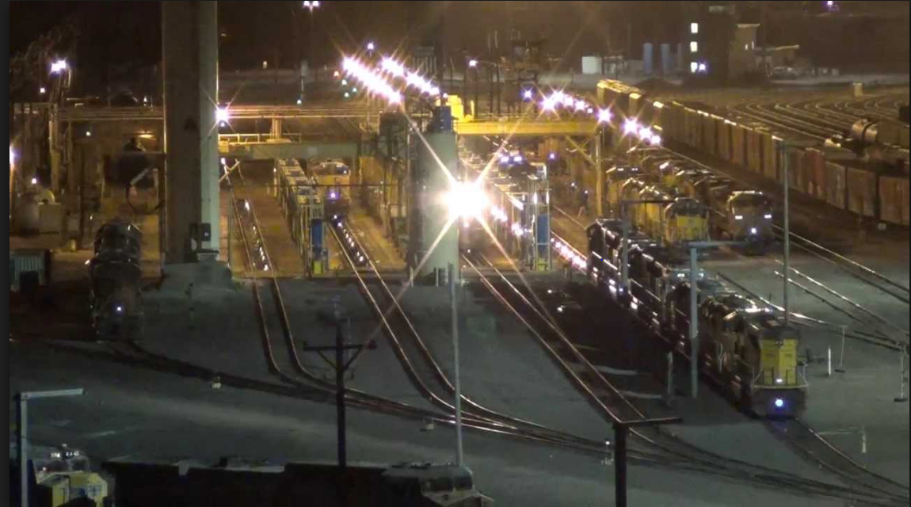

Bailey Yard
Union Pacific’s Bailey Yard in North Platte, Neb., is the largest railroad classification yard in the world. Named in honor of former Union Pacific President Edd H. Bailey, the massive yard covers 2,850 acres, reaching a total length of eight miles. The yard is located in the midst of key east-west and north-south corridors, making it a critical component of Union Pacific’s rail network.

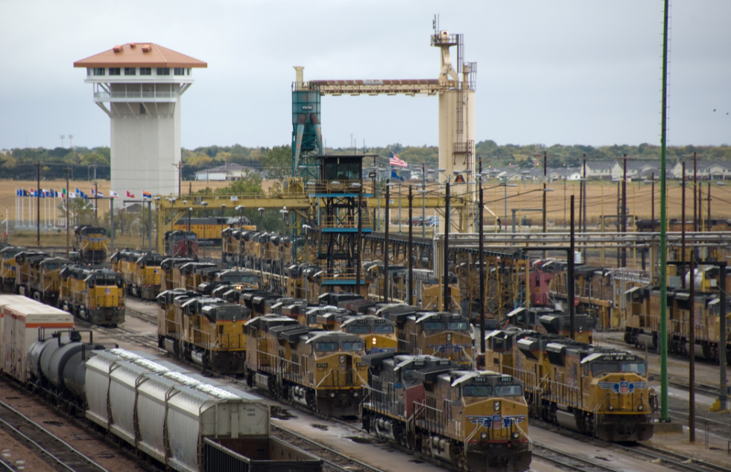
Bailey Yard has 17 receiving and 16 departure tracks handling 14,000 rail cars every 24 hours. Of those, about 3,000 cars are sorted daily in the yard’s eastward and westward yards, nicknamed "hump" yards. Using a mound cresting 34 feet for eastbound trains and 20 feet for those heading west, the hump yards allow four cars a minute to roll gently into any of 114 "bowl" tracks. Here they become part of trains headed for destinations in the East, West and Gulf Coasts of America, as well as the Canadian and Mexican borders. An average of 139 trains per day, comprised of raw and finished goods, such as automobiles, coal, grain, corn, sugar, chemicals, steel and consumer goods, including electronics, apparel and other retail products, are handled at Bailey Yard.

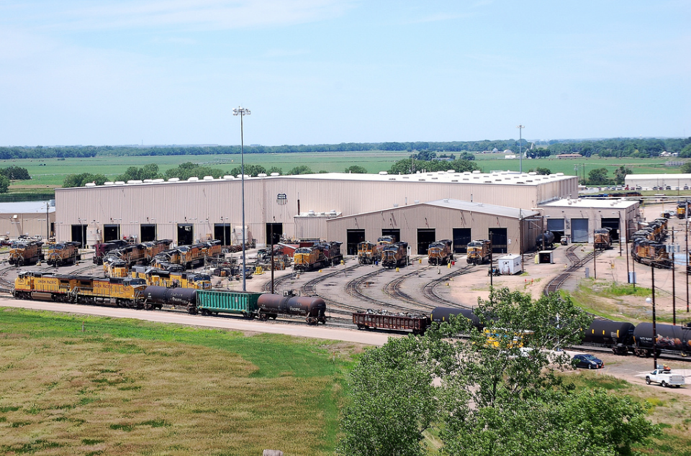
To keep America moving, train operations and repair shops at Bailey Yard are open 24 hours a day, seven days a week. The fueling and service center processes more than 9,000 locomotives each month, using technology like overhead cranes and elevated work bays to maintain fluid operations.

Feather River Winery & Grain Bin Antique Town Tour
r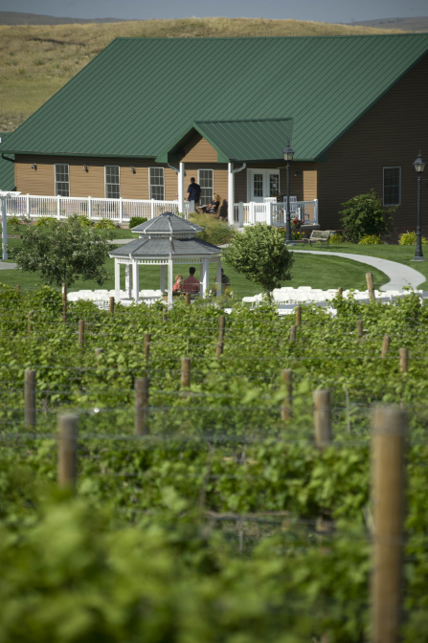
Feather River Vineyards is owned by Jeff and Connie Brittan and Kurt and Jeanne Pieper. One of Nebraska's largest vineyards, they first planted vines in 2001 in the Loess Hills, south of North Platte. This beautiful scenic area has been a perfect spot to enjoy western Nebraska's newest wines, plus a scenic stopping point for area locals, statewide travelers and wine enthusiasts from across the country.

The 37 acres include a bevy of grape varieties including Edelwiess, Seyval, Reisling, LaCrosse, St Pipen, Marechal Foch, Frontanec, St. Croix, and Marguette. Response was astounding to the vineyard placed in the middle of the heartland and our enticing winery soon followed and was built in 2006. The Feather River Winery includes a tasting room with a veranda, production area, lab and offices. Enjoy a 'taste' of the Good Life and visit the Feather River Winery & Vineyard. They are able to handle a variety of events and the vineyard and grounds are available for weddings, receptions, parties and dinners.
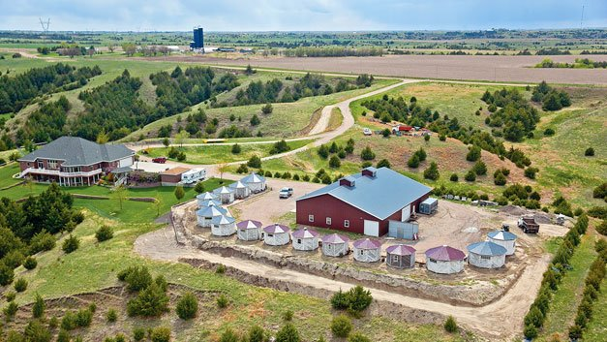
Located in the beautiful hills south of North Platte, NE the Grain Bin Antique Town management is confident that you’ll enjoy the beauty that surrounds them as much as their antiques. In the spring of 2012, the Grain Bin embarked upon an adventure that began with re-locating and restoring 20 historic, wooden and octagon granaries. They have been stocking and filling them full of fantastic finds ever since. The Bins, each full of a wonderful selection of antiques, are connected by a board walk of 100 year old Douglas Fir timber that tie them together to really give the feel of a vintage town. They have many old farm items, decorative iron pieces, glassware and antiques for everyone.
North Platte Hydro Plant Tour

Farmers in Nebraska, near the turn of the 20th century, did not have enough water to keep up with increasing irrigation demands. In 1933, when the Nebraska Legislature authorized the formation of public power districts in Nebraska, several farmers and businessmen formed public power and irrigation districts. These districts built a series of reservoirs, dams and canals to deliver water to farms in Nebraska.

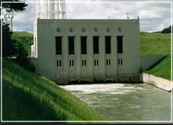North Platte Hydro – the largest NPPD-owned hydro in terms of capacity, the North Platte hydro has been operating since 1937. The hydro has two General Electric generators and two Allis Chalmers turbines that can produce 12,000 kilowatts each, for a total output of 24,000 kilowatts. The water used at the hydro comes from the North and South Platte River(s). After flowing through the hydro, the water reenters the South Platte River and powers other hydros and irrigation needs downstream. The hydro generated 175,604 MWh of electricity in 1997 surpassing the previous record, set in 1987, by 10,421 MWh.

Gerald Gentleman Station Tour

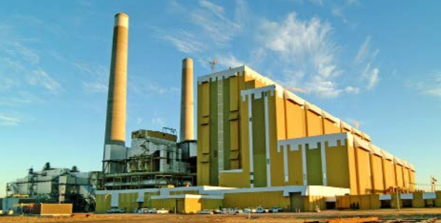Gerald Gentleman Station (GGS) is Nebraska’s largest generating plant. Located near Sutherland, Nebraska, the plant consists of two coal-fired generating units, which together have the capability to generate 1,365 megawatts of power. While NPPD can place the awards in a showcase, NPPD’s customers are the real winners. In addition to generation records, plant employees also continue to set safety records. In recent years, Gerald Gentleman Station has been recognized by Platts Power magazine as the lowest cost coal-fired producer in America.
Coal from Wyoming’s Powder River Basin provides fuel for the plant. NPPD built a second rail spur to the plant in 1994 so coal can be shipped directly from Union Pacific or Burlington Northern railroad lines. The new spur increases competition in the freight market resulting in lower costs for coal delivery to GGS, which at full capacity, burns as much as 800 tons of coal per hour.
GGS meets all federal and state air pollution and water quality regulations. The station burns low-sulfur coal, which greatly reduces the discharge of sulfur dioxide gases in to the air. GGS also helps protect the environment through its reverse gas (sonic horn assisted) cleaning baghouses, which remove particulates from flue gas emissions. Additional on-site pollution control measures include a sewage treatment plant and a waste-water evaporation pond. The plant has also used environmentally-focused coal storage and handling operations, like covering inactive coal piles with grasses to reduce the blowing of coal dust. The clean and safe environment maintained by GGS contributes to an increase in the natural habitation and recreational value of nearby Sutherland Reservoir.

Great Plains Health Tour
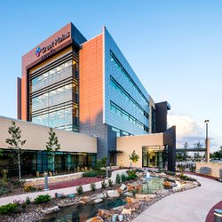Great Plains Health is a progressive health system located in North Platte serving a 17-county region of Nebraska, northern Kansas and southern South Dakota. Answering our community’s call for local access to advanced care that is safe, high quality and cost efficient has resulted in our growth to include:
- A 116-bed, not-for-profit, independent, community-owned regional medical center
- Twelve Great Plains Physician Network medical clinics in North Platte
- Fifteen outreach clinics in communities throughout west central Nebraska
- Great Plains Home Medical Equipment
- Regency Retirement Community
- Great Plains Health Care Foundation
With 90 physicians representing nearly 30 medical specialties, the Great Plains Health system offers advanced health care, including heart and vascular, cancer and orthopedic surgery services. Great Plains Health features a level III trauma center with all of its emergency room physicians board certified and residency trained in emergency medicine. We have approximately 1,087 employees and 130 volunteers. Our primary and secondary service area spans approximately 16,000 square miles and 120,000 people.
Great Plains Health is the only hospital in Nebraska to receive an A rating for patient safety from The Leapfrog Group in its fall 2013 surveys. The hospital is accredited by the Joint Commission and is home to an American College of Surgeons accredited cancer center and level 2 bariatric surgery program.

Walmart Distribution Center
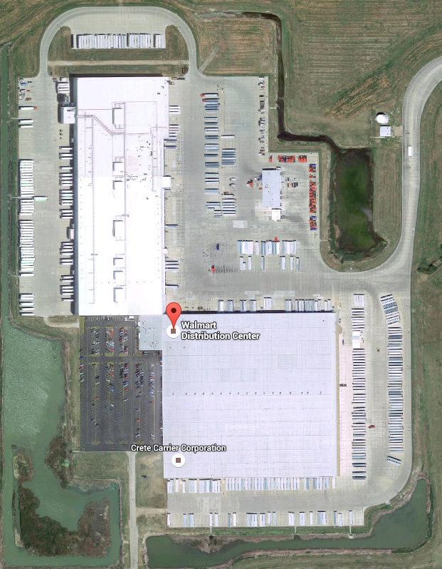
More than 50 years ago, Sam Walton started the tradition of hiring the best and brightest when he opened the first store in Rogers, Arkansas. And since 1962, Walmart has been dedicated to helping people in communities save money so they can live better.
So, what’s the secret to their success? As Mr. Sam once said, “Our people make the difference.” Walmart associates have helped expand their physical and digital retail presence. And they continue to redefine the industry – from new apps that help customers save money and smaller-format retail stores, to enabling easier, more efficient online shopping and their push to become supplied 100% by renewable energy.
Walmart has several types of distribution centers that support Walmart and Sam’s Club operations. They believe it’s the most advanced retail distribution network in the world.
- Regional Distribution Centers are the heart and soul of their logistics operations. The average "D.C." serves 90-100 stores in their region. 42 facilities utilize 12 miles of conveyor belts to keep products moving.
- Fashion, Optical, Jewelry, and Grocery Distribution Centers are each unique facilities. As their names imply, they support Walmart stores and other distribution centers by shipping specialized products to their network.
- Fulfillment Centers make Walmart's vision of "a seamless shopping experience at scale" possible by offering fast shipping to both homes and stores—whatever ways their customers choose.

