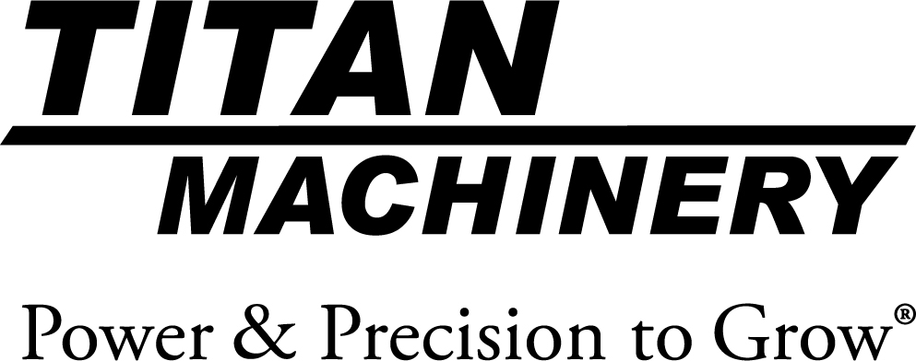

Business Description:
Titan Machinery Inc., founded in 1980 and headquartered in West Fargo, North Dakota, owns and operates a network of full service agricultural and construction equipment dealer locations in North America and Europe. The network consists of US locations in Arizona, Colorado, Iowa, Minnesota, Montana, Nebraska, North Dakota, South Dakota, Wisconsin and Wyoming and its European stores are located in Bulgaria, Germany, Romania, Serbia and Ukraine. The Titan Machinery locations represent one or more of the CNH Industrial Brands, including Case IH, New Holland Agriculture, Case Construction, New Holland Construction, and CNH Industrial Capital. Additional information about Titan Machinery Inc. can be found at www.titanmachinery.com.

Video’s:
Company Video: https://youtu.be/bVpHajLFyS0
Service Technician Video: https://youtu.be/FoCWd1XG_KM
Business Operations (corporate) Internship Video: https://youtu.be/InfGxGrZX1I

